Email
Student’s Name
Institution Affiliation
Date

Email
Subject: Findings on Telecommunication Services
To whom it may concern,
Most telecommunication services use social media platforms such as Facebook to have an interactive session with their clients. Clients have a chance to give their feedback on the product they are using from specific telecom industries. Research on the Verizon Facebook page provides a sample that shows telecom companies interact with their consumers.
1. Telecom companies have a system that allows the consumer to provide feedback on the efficiency of their services.
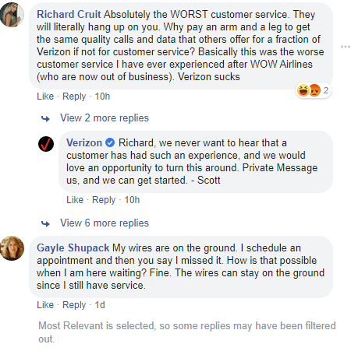
- Social media provides a platform for consumers to initiate a conversation as well as develop it with their telecom providing companies.

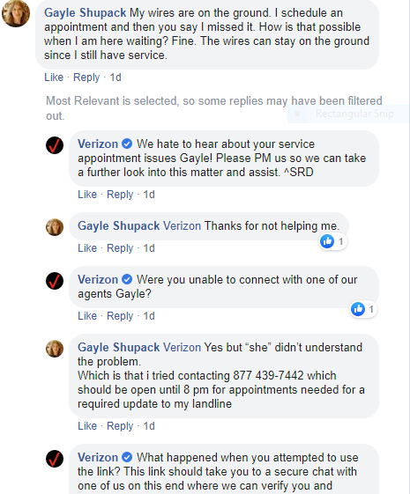
The research finding of Verizon Telecom Company portrays how social media platform gives a chance for consumers to provide feedback on the kind of telecom service they receive. Besides, the companies get an opportunity to interact with their consumers and work on their product service flaws.
Sincerely,
Name.

